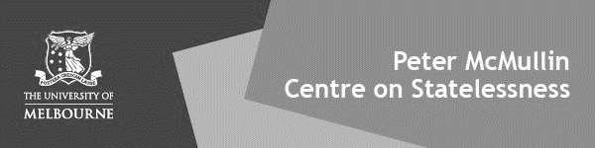
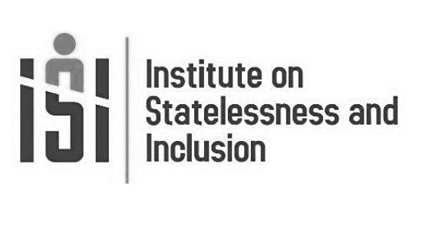
2021 Editorial Team

Editors in Chief

Professor Michelle Foster
Peter McMullin Centre on Statelessness, Melbourne Law School (Australia)
Dr Laura van Waas
Institute on Statelessness and Inclusion (The Netherlands)

Case Note Editor
Dr Katia Bianchini
Researcher, Max Planck Institute for Social Anthropology, Department of Law and Anthropology, Halle (Saale, Germany)
Critique and Comment Editor
Professor Jamie Liew
Director, Institute of Feminist and Gender Studies, University of Ottawa (Canada)

Book Review Editor
Dr Barbara von Rütte
Postdoctoral Research Fellow, Institute for European Global Studies, University of Basel (Switzerland)

Managing Editors

Maria Jose Recalde-Vela
PhD Researcher, Tilburg Law School and Programme Officer (Volunteer), Institute on Statelessness and Inclusion (The Netherlands)
Jade Roberts
PhD Researcher, Peter McMullin Centre on Statelessness, Melbourne Law School (Australia)

Production Manager

Eliah Castiello
Research Fellow, Peter McMullin Centre on Statelessness, Melbourne Law School (Australia)

2021 Editorial Team

Production Editors

Ingrid Bennett
JD Candidate, The University of Melbourne Law School (Australia)
Bree Booth
JD Candidate, The University of Melbourne Law School (Australia)
Bella Ruskin
JD Candidate, The University of Melbourne Law School (Australia)
Kalinda Scheef
JD Candidate, The University of Melbourne Law School (Australia)

Citations Managers
Peter Clynes
JD Candidate, The University of Melbourne Law School (Australia)

Shruti Sudarsan
JD Candidate, The University of Melbourne Law School (Australia)

Senior Copy Editor
Victor Sun
JD Candidate, The University of Melbourne
Law School (Australia)

Copy Editors

Michael Bell | Eilidh Kirk
Ilaria Bigaran | Andy Kuoch
Shyamni Chokshi | Inna Kuzminykh
Julia Despard | Wilson Lee
Shi-Mei Ewing | Alexandra McKinnon
Joy-Helena Ferrari | Calin Miles
Jasmine Gan | Jonathan Ta
Elle Henriksen | Emily Tsang
Andrew Herrmann | Amelia Walters
Kaitlin Jempson | Rachel Walters
Hannah Joyce | Celene Wong
Andrew Kembe

Editorial Board
Dr Edwin Abuya
Associate Professor at the School of Law, University of Nairobi (Kenya)
Dr Seth Anziska
Mohamed S Farsi-Polosnky Lecturer in Jewish–Muslim Relations, University College London (UK)
Professor Osamu Arakaki
PhD Professor of International Law at International Christian University (Japan)
Mr Fateh Azzam
Human Rights Consultant; Executive Member, Boston Consortium for Arab Region Studies (USA)
Professor Matthew J Gibney
Professor of Politics and Forced Migration, Refugee Studies Centre, University of Oxford (UK)
Professor Penny Green
Professor of Law and Globalisation, and Director of the International State Crime Initiative, Queen Mary University of London (UK)
Professor Dr Gerard-René de Groot
Emeritus Professor of Comparative Law and Private International Law, Maastricht University (Netherlands); Professor of Private Law, University of Aruba (West Indies)
Professor Linda Kerber
May Brodbeck Professor in the Liberal Arts and Professor of History, Emerita, University of Iowa (USA)
Professor Audrey Macklin
Director of the Centre for Criminology and Sociolegal Studies and Professor and Chair in Human Rights, University of Toronto (Canada)
Dr Bronwen Manby
Visiting Senior Fellow, Centre for the Study of Human Rights, London School of Economics (UK)
Dr Parivelan KM
Associate Professor & Chairperson, Nodal Centre of Excellence for Human Rights Education & Centre for Statelessness and Refugee Studies, School of Law, Rights and Constitutional Governance, Tata Institute of Social Sciences (India)
Dr Nando Sigona
Senior Lecturer & Birmingham Fellow and Deputy Director, Institute for Research into Superdiversity, University of Birmingham (UK)
Professor Julia Sloth-Nielson
Professor, Department of Public Law and Jurisprudence, University of the Western Cape (South Africa) and Professor of Children's Rights in the Developing World, University of Leiden (Netherlands)
Professor Kim Rubenstein
Professor of Law and Public Policy Fellow, Australian National University (Australia)
Professor Peter Spiro
Charles Weiner Professor of Law, Temple University Law School (USA)
Artwork: Critical Mass
The featured artwork on our website was submitted as part of an open call for pieces responding to the Review’s focus on advancing understandings of statelessness and citizenship phenomena and challenges. ‘Critical Mass’ has been developed by architect and artist Wasim Z Habashneh. The artist’s statement is as follows:
Using the traditional sand art practiced in Jordan to fill discarded fluorescent tubes with pixelated patterns.
This pattern reflects the critical mass, a term that indicates the sufficient number of adopters of innovation in a social system, so that the rate of adoption becomes self-sustaining and creates further growth. The layers of sand are positioned to resemble the transition phase of a critical mass affecting the existing mass.
The sand particles resemble the human presence and necessity in such an environment.
The piece questions the definition of a normal and healthy community: statelessness and citizenship are now an inevitable reality in our world, therefore finding ways to include them in our collective pattern is as important as retaining the current one.

Submissions
The Statelessness & Citizenship Review is an online, open source academic journal that publishes two issues per year. Please send an electronic copy of your submission, preferably in Microsoft Word format, to the Editors in Chief at:

<info@screview.net>
All articles, critique and comments and case notes published are refereed. Other pieces are refereed at the discretion of the Editors in Chief.

Online Resources
All pieces in this issue are available from our website:
<statelessnessandcitizenshipreview.com>
All URLs cited in this issue are active as of December 2021.

Citations
This issue has been cited in accordance with the fourth edition of the Oxford University Standard for the Citation of Legal Authorities (‘OSCOLA’) as supplemented by the Review’s House Rules on grammar, punctuation and citation.

This volume and issue may be cited as:
(2021) 3(2) Statelessness & Citizenship Review
© Peter McMullin Centre on Statelessness and Institute on Statelessness and Inclusion 2021
All rights by all media reserved

Table of Contents

Articles

Refusing Refusal: The Struggles of Stateless Palestinians in the Swedish Migration Regime
Helena Lindholm | 267
Sea Level Rise and Climate Statelessness: From ‘Too Little, Too Late’ to Context-Based Relevance
Michel Rouleau-Dick | 287
Tanah Tumpahnya Darahku: The ‘Genuine and Effective Link’ in Establishing Malaysian Citizenship
Tan Kian Leong | 309
‘I Must Be from Somewhere. I’m Not from the Moon’: Navigating the Politics of Labelling for Stateless Palestinian Refugees from Syria
Jason Tucker and Haqqi Bahram | 330
Critique and Commentary

Legal Identity and Minority Statelessness in Cambodia: Recent Developments
Christoph Sperfeldt | 347
Book Reviews

Statelessness and Contemporary Enslavement by Jane Anna Gordon (Routledge 2019). 164 Pages. Price USD $34.36. ISBN 9780367358549
Yuriko Cowper-Smith | 354
Statelessness, Governance, and the Problem of Citizenship, Edited by Tendayi Bloom and Lindsey N Kingston (Manchester University Press 2021) 400 Pages. Price £90.00. ISBN 9781526156419
Marnie Lloydd | 359
Legal Identity, Race and Belonging in the Dominican Republic: From Citizen to Foreigner by Eve Hayes De Kalaf (Anthem Press 2022) 126 Pages. Price $40.00. ISBN 9781785277641
Allison J Petrozziello | 366

